GENERAL description

xMotion P3

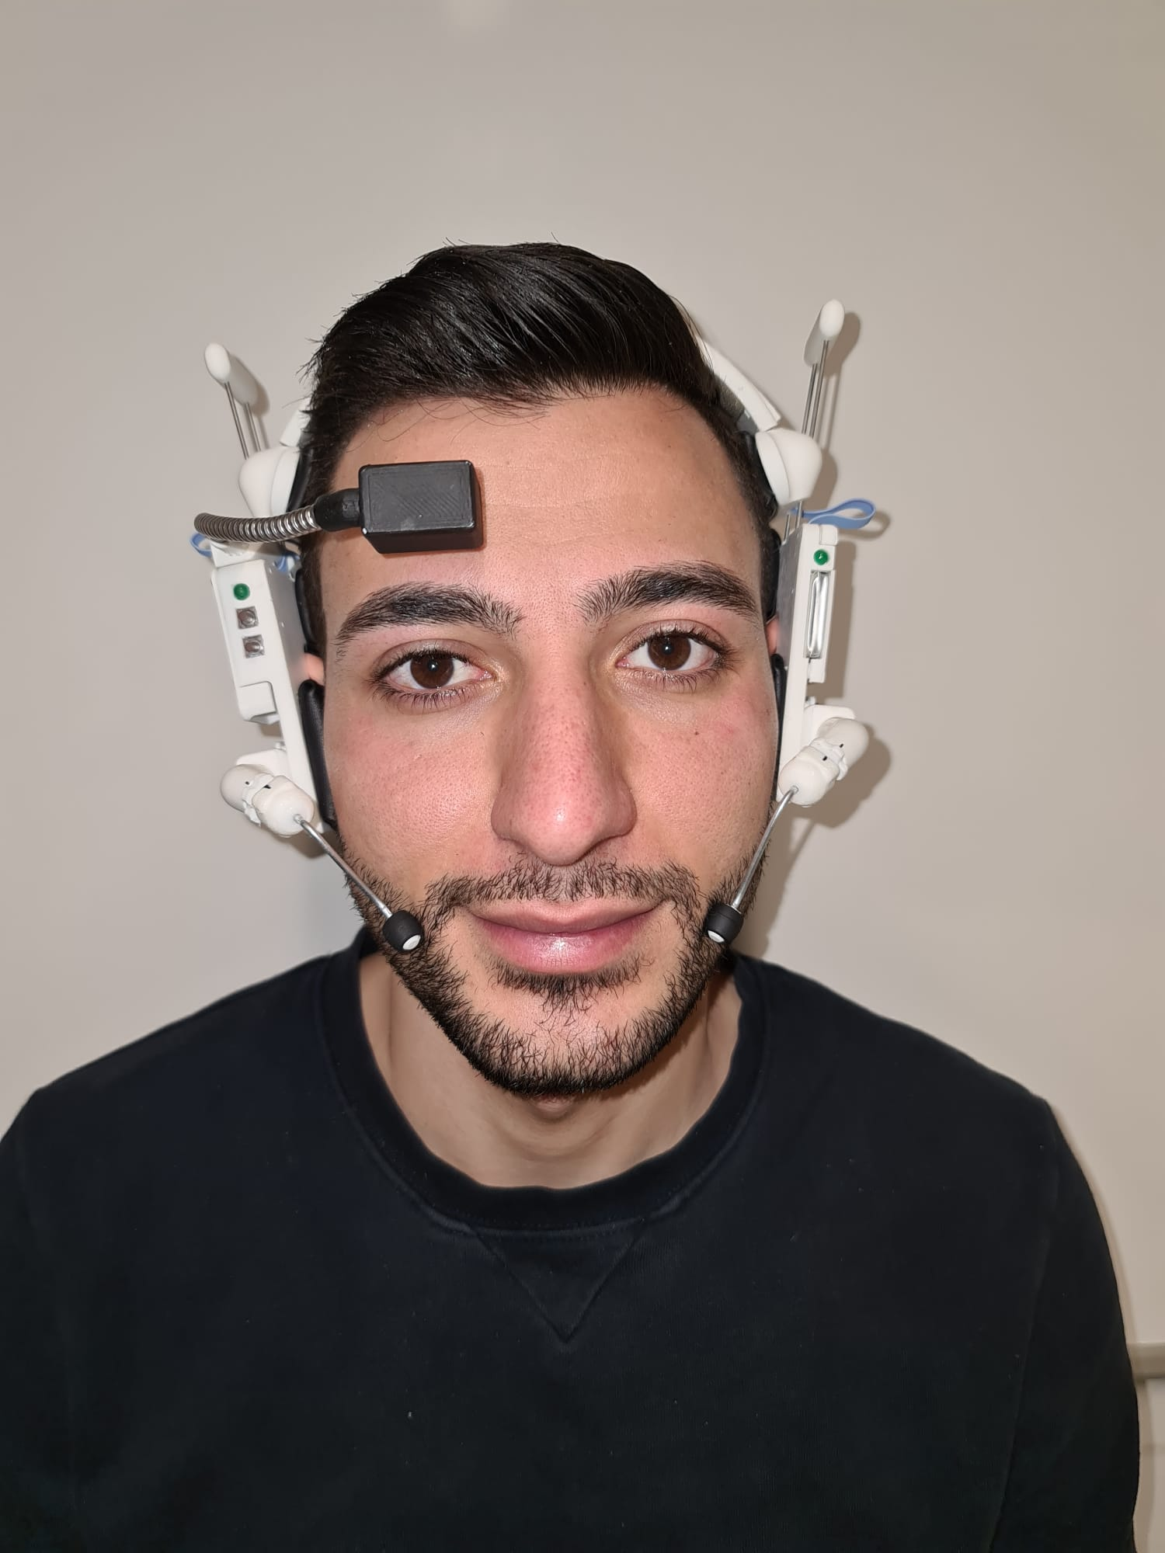

**xMotion – Prototype 3 (P3)**

**P3** is a fully adjustable light-weight wireless headset that measures voluntary movements of the face and translates them into mouse/keyboard commands sent via Bluetooth Low Energy (BLE) to any PC, iOS or Android device.

**P3** consists of a padded headband (1) designed to provide extensive-use comfort; two hubs (2, 4) housing an Arduino-compatible Bluefruit nRF52 Feather board that is automatically recognized via BLE as a human-interface device (HID) by any PC, iOS or Android device, and a rechargeable built-in battery that delivers hours of wireless use in a single charge; and three probes (3, 4, 6) that detect voluntary movements of the face. Two mechanical contact probes (3, 4) capture orofacial movements bilaterally via magnetic-based sensing, and a contactless probe (6) captures forehead movements via optical sensing.

Designed for easy setup, **P3** is calibration-free and only requires an initial mechanical adjustment to ensure a stable and comfortable fit for all-day use of mainstream devices without hands.

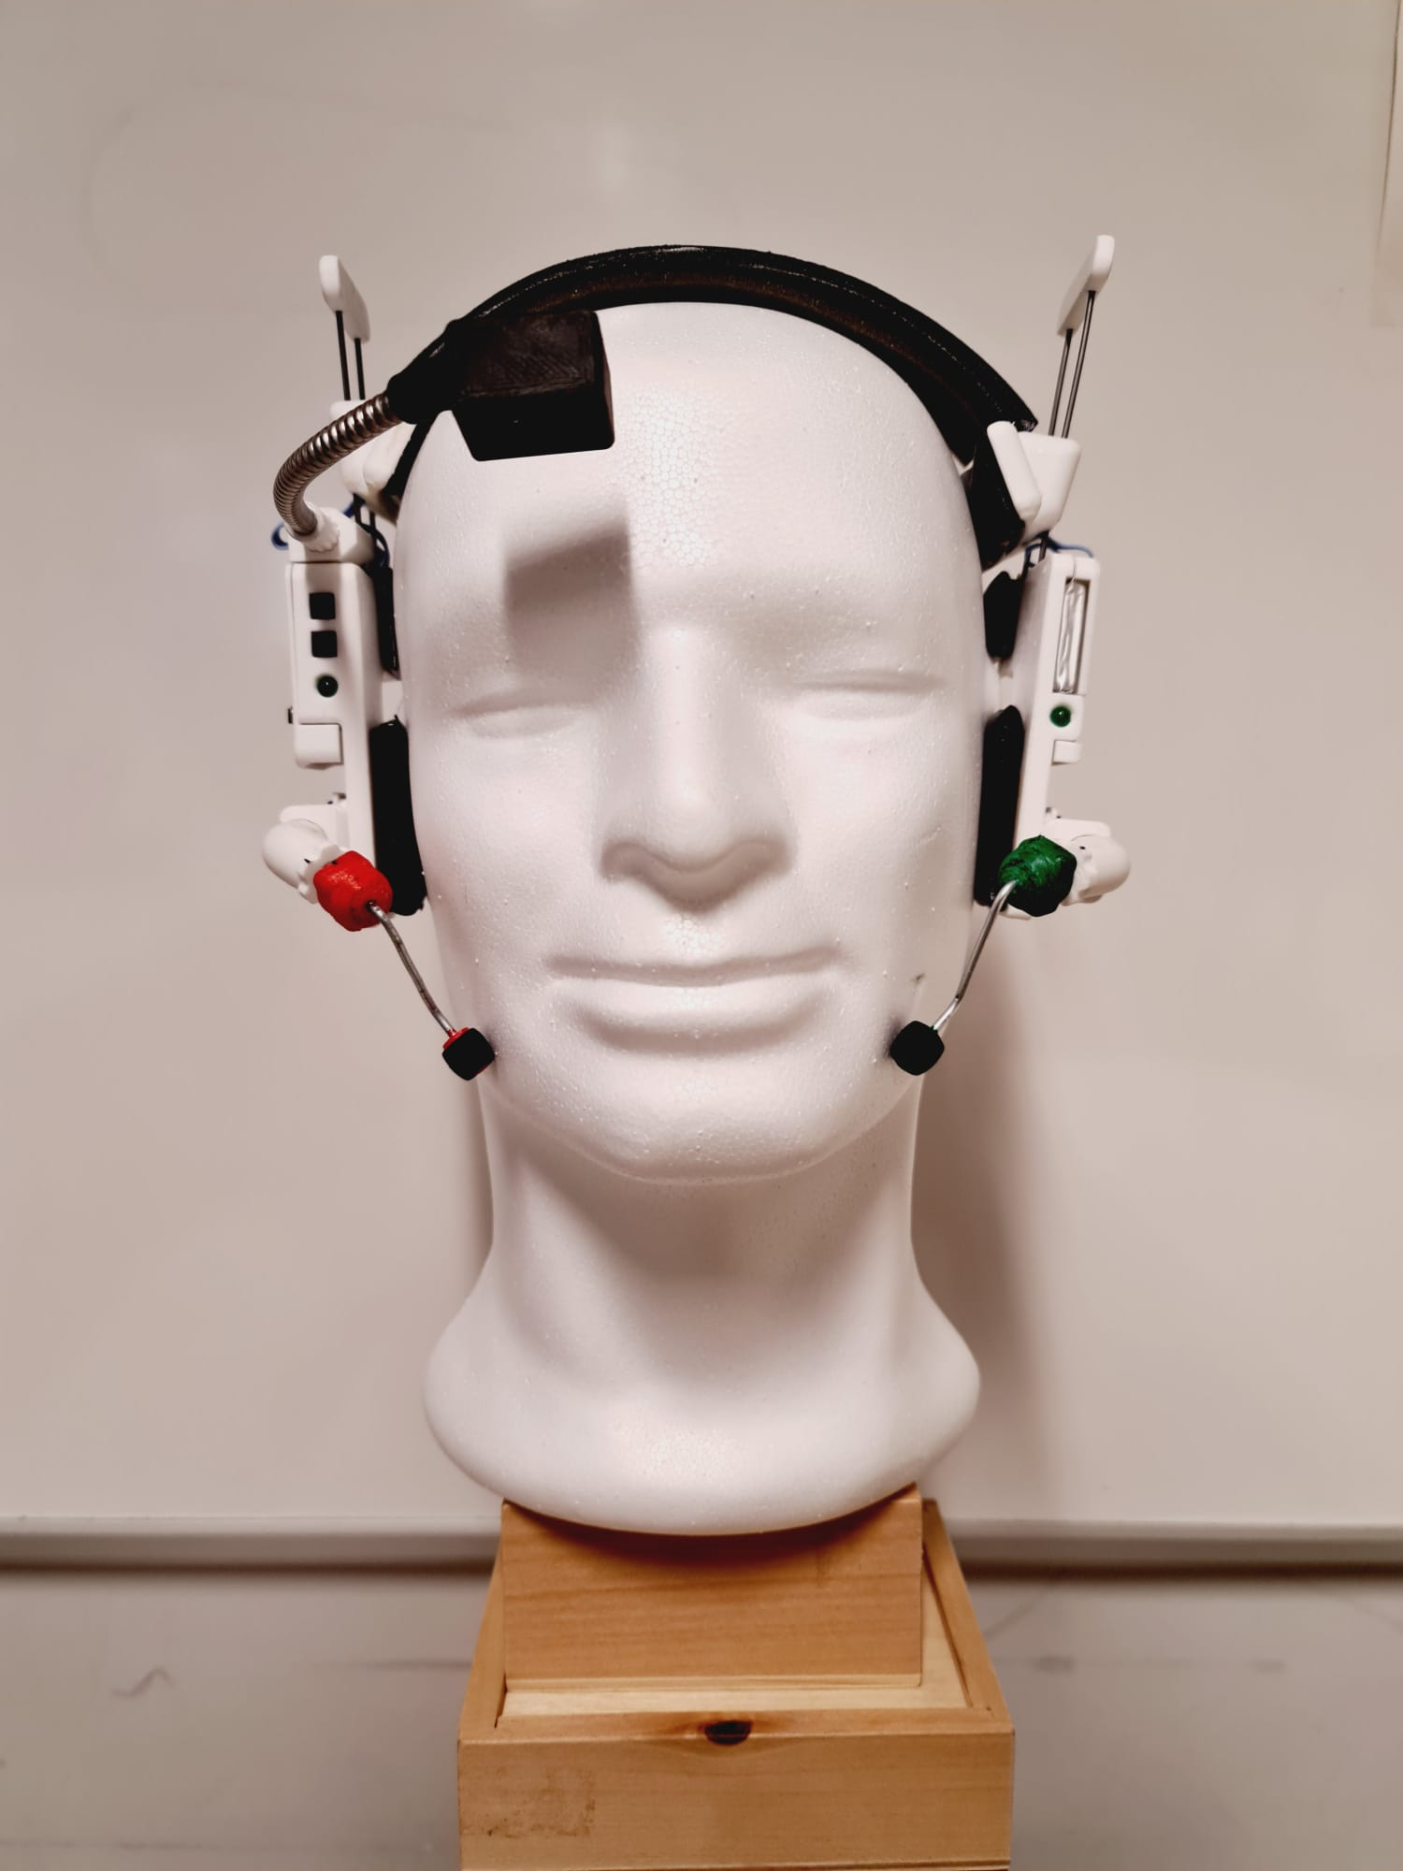

5

4

1

2

1

6

3

**P3 components. (1)** Head band; **(2)** Left hub; **(3)** Left magnetic probe; **(4)** Right magnetic probe; **(5)** Right hub; **(6)** Optical probe.

Assembly description

## **xMotion P3**

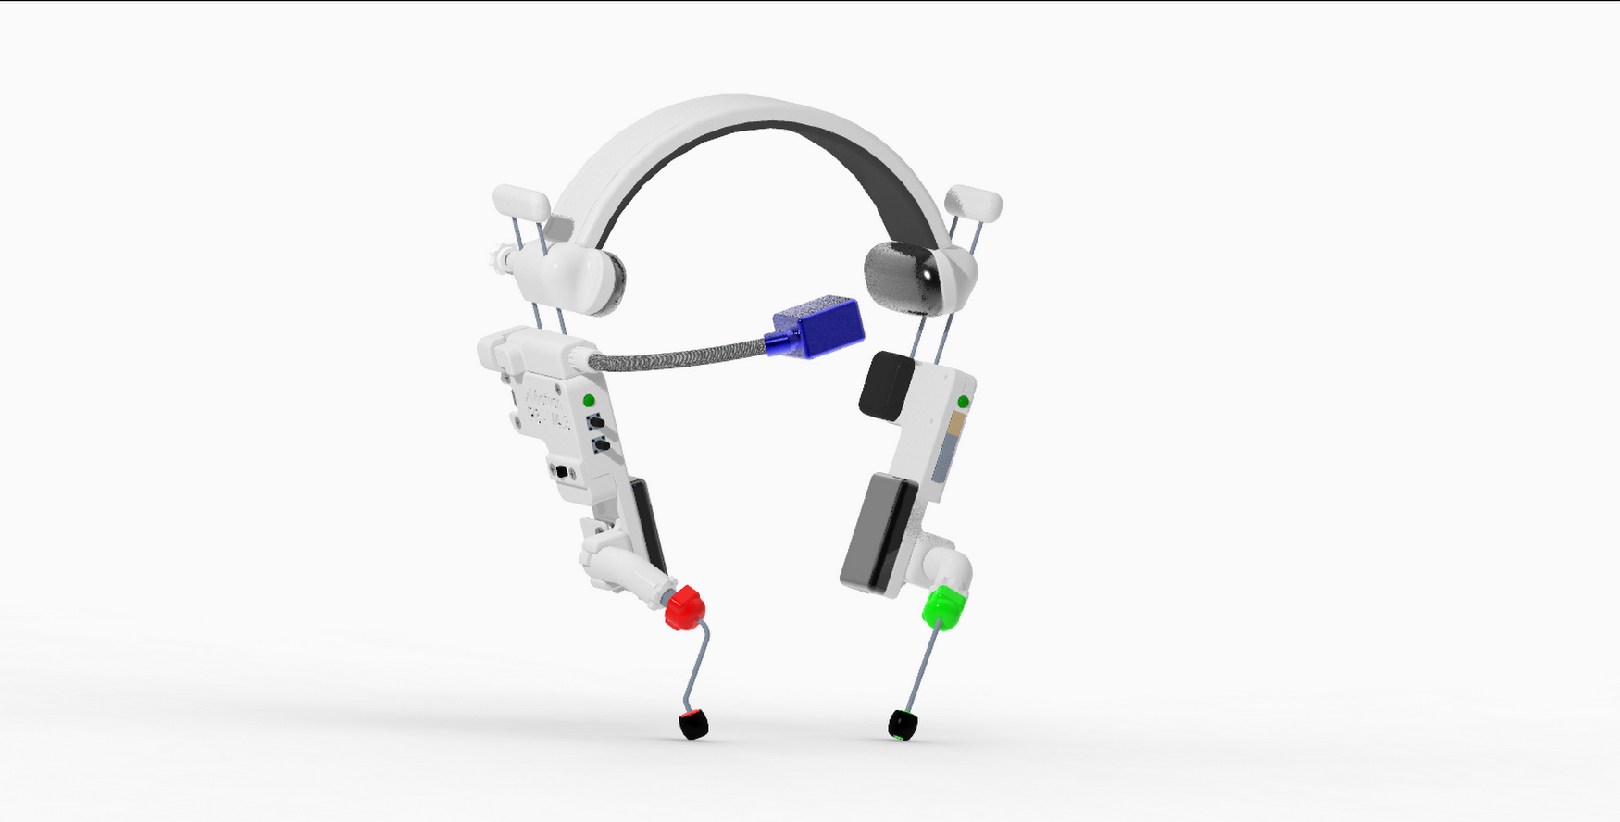

Contents

**xMotion P3** 3

General assembly 5

1. Headset band sub-assembly 6

Fabrication process 7

2. Right Hub sub-assembly 8

Fabrication process 9

3. Left Hub sub-assembly 11

Fabrication process 12

4. Magnetic probe sub-assembly 13

Fabrication process 14

5. Optical probe sub-assembly 17

Fabrication process 18

Optical sensor circuit schematic 20

PCB optical sensor Layout 21

PCB optical sensor parts list (PCB-PL) 21

Electronic parts list (EPL) 22

General circuit schematic 23

Mechanical parts list (MPL) 24

Printed parts list (PPL) 25

## General assembly

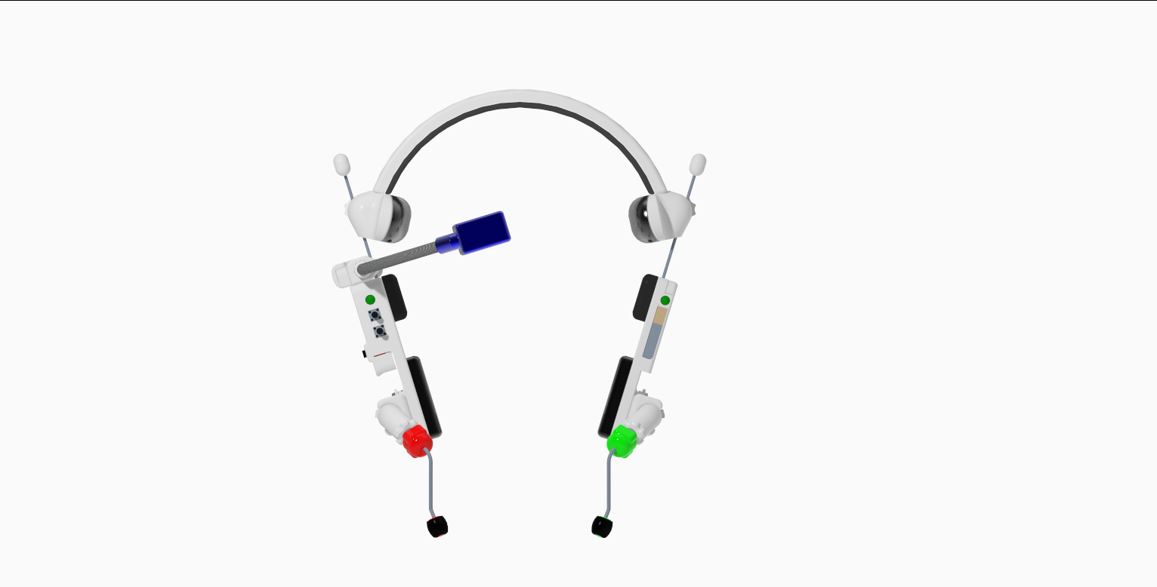

1

3

4

2

5

|  |  |  |  |
| --- | --- | --- | --- |
| N° | Part description | Abbreviation | Quantity |
| 1 | Headset band sub-assembly | HB | 1 |
| 2 | Right hub sub-assembly | RH | 1 |
| 3 | Left hub sub-assembly | LH | 1 |
| 4 | Magnetic probe sub-assembly | MP | 2 |
| 5 | Optical probe sub-assembly | OP | 1 |

## Headset band sub-assembly

The padded headset band ensures stable yet adjustable (Right and Left hubs) functionality for all-day comfort.

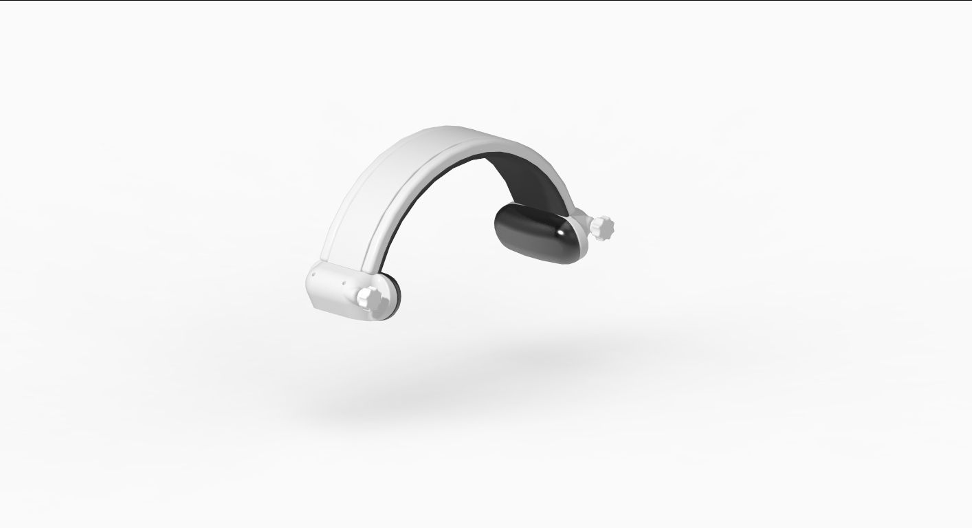

|  |  |  |  |  |  |  |  |  |  |  |  |  |  |  |  |  |  |  |  |  |  |
| --- | --- | --- | --- | --- | --- | --- | --- | --- | --- | --- | --- | --- | --- | --- | --- | --- | --- | --- | --- | --- | --- |
| 1.1  1.2  1.3  1.7  1.5  1.9  1.8  1.4  1.6 | |  |  | | --- | --- | | N° | Part description | | 1.1 | Flexible top cover | | 1.2 | Curved spring wires (3x) | | 1.3 | Right side node | | 1.4 | Allen screw M3x10 (2x) | | 1.5 | Side padding (2x) | | 1.6 | Left side node | | 1.7 | Locking wheel (2x) | | 1.8 | Flexible headband | | 1.9 | Top padding | |

### Fabrication process

MATERIALS NEEDED can be found in Mechanical Part List (MPL, page 24), Printed Parts List (PPL, page 25) and Electronical part list (EPL, page 22)

|  |  |  |
| --- | --- | --- |
| Step | Description | Materials needed |
| 1 | **Curved spring wires *(Part N°1.2)***  Bend the three spring wires as illustrated with a bending radius of 80 mm and cut them to an angle of 140°. | * Spring wires of Ø1.6 mm *(MPL N°2)* * Pattern for each wire: |
| 2 | **Headband assembly *(Parts N°1.1, 1.2, 1.3, 1.6, 1.8)***   1. Insert two of the three curved spring wires *(Part N°1.2)* into the flexible headband. 2. Slide them into the two side nodes (right/left) *(Parts N°1.3, 1.6)* connecting the nodes with the flexible headband *(Part N°1.7).* 3. Insert the third spring wire *(Part N°1.2)* into each side node *(Parts N°1.3, 1.6)* and cover up with the flexible top cover *(Part N°1.1).* A pair of pliers may be helpful. | * Curved spring wires (3x) *(Step 1.1)* * Flexible headband *(PPL N°5)* * Flexible top cover *(PPL N°1)* * Right side node *(PPL N°2)* * Left side node *(PPL N°3)* * Flat pliers (Tool) |
| 3 | **Padding *(Parts N°1.5, 1.9)***   1. Side padding *(Part N°1.5):* Cut (2x) memory foam pieces of 12 mm thickness as illustrated. 2. Top padding *(Part N°1.9):* Cut (1x) thin foam of 3 mm thickness with the pattern of the top foam as illustrated. 3. Cover the foams from steps 1.3.1 and 1.3.2 with thin tissue using a sew machine. 4. Attach the covered foams from step 1.3.3 to the side nodes *(Parts N°1.3, 1.6)* and the flexible headband *(Part N°1.7)* with double tape. | * Memory foam *(MPL N°3)* * Side padding pattern:      * Thin Foam *(MPL N°4)* * Top padding pattern:      * Thin tissue for covering *(MPL N°6)* * Sew machine (Tool) * Pair of scissors/cutter (Tool) * Headband assembly *(Step 1.2)* * Double tape |
| 4 | **Locking screws *(Parts N°1.4, 1.7)***   1. Assemble the locking screws (2x) by fixing the locking wheel *(Part N°1.7)* on the head of the Allen screw *(Part N°1.4).* 2. Screw them on each side node *(Parts N°1.3, 1.6).* When fully screwed, they will lock the sliding straight wires from the right/left hubs sub-assembly *(Parts N°2, 3)* into the desired position. | * Allen screw M3x10 *(MPL N°1)* * Locking wheel *(PPL N°4)* * Headband assembly *(Step 1.2)* * Right hub *(Part N°2)* * Left hub *(Part N°3)* |
| 5 | **Electrical wiring**  Insert and slide the flat cable through both side nodes *(Parts N°1.3, 1.4)* and the flexible headband *(Part N°1.8).* The flat cable will connect both hubs *(Parts N°2, 3)*. | * 6-contacts flat cable *(EPL N°13)* * Headband assembly *(Step 1.2)* |

## Right Hub sub-assembly

The right hub is topped with two straight spring wires *(Part N°2.5)* that slide within the corresponding righ side node *(Part N°1.3).* The sliding range allows fine adjustement for stable and comfortable fit. The right hub houses a microcontroler Bluefruit nRF52832 feather *(Part N°2.4),* a sliding ON/OFF switch *(Part N°2.11),* two push-buttons *(Part N°2.7),* a green LED *(Part N°2.6),* a QWIIC I2C *(Part N°2.12)* adapter and wired connections.

|  |  |
| --- | --- |
|  |  |

|  |  |  |  |  |  |  |  |  |  |  |  |  |  |  |  |  |  |  |  |  |  |  |  |  |  |  |  |
| --- | --- | --- | --- | --- | --- | --- | --- | --- | --- | --- | --- | --- | --- | --- | --- | --- | --- | --- | --- | --- | --- | --- | --- | --- | --- | --- | --- |
| 2.3  2.2  2.1  2.4  2.6  2.7  2.8  2.9  2.5  2.122  2.11  2.10 | |  |  | | --- | --- | | N° | Part description | | 2.1 | Right hub cover | | 2.2 | Flat head screw M2.5x8 (5x) | | 2.3 | Hub end part | | 2.4 | Bluefruit nRF52832 feather | | 2.5 | Straight spring wire (2x) | | 2.6 | Green LED | | 2.7 | Push-button (2x) | | 2.8 | Right hub holder | | 2.9 | Bottom padding | | 2.10 | Top padding | | 2.11 | Slide switch ON/OFF | | 2.12 | QWIIC I2C ADAPTER | |

### Fabrication process

MATERIALS NEEDED can be found in Mechanical Part List (MPL, page 24), Printed Parts List (PPL, page 25) and Electronical part list (EPL, page 22)

|  |  |  |
| --- | --- | --- |
| Step | Description | Materials needed |
| 1 | **Straight spring wires *(Part N°2.5)***   1. Cut (4x) 90 mm long straight spring wires (Another pair for the left hub). 2. Insert (2x) the bottom end of the straight spring wires *(Part N°2.5)* into the right hub holder *(Part N°2.8).*   A pair of pliers may be helpful. | * Spring wire of Ø1.6 mm *(MPL N°2)* * Right hub holder *(PPL N°6)* * Flat pliers (Tool) |
| 2 | **Padding *(Parts N°2.9, 2.10)***   1. Top padding *(Part N°2.10):*   Cut (2x) memory foam of 12 mm thickness as illustrated (one for the Left hub).   1. Bottom padding *(Part N°2.9):*   Cut (2x) memory foam of 12 mm thickness as illustrated aside (one for the Left hub).   1. Cover the foams from step 2.2.1 and 2.2.2 with thin tissue using a sew machine. 2. Attach one pair of the covered foams from step 2.2.3 to the back side of the right hub holder *(Part N°2.8)* with double tape within the specified areas. | * Memory foam *(MPL N°3)* * Top padding pattern:      * Bottom padding pattern:      * Thin tissue for covering *(MPL N°6)* * Sew machine (Tool) * Pair of scissors or cutter (Tool) * Double tape |
| 3 | **Electrical wiring *(Parts N°1, 2.4, 2.6, 2.7, 2.11, 2.12)***   1. Connect the Green LED *(Part N°2.6)*, the two Push-button *(Part N°2.7)*, the ON/OFF switch *(Part N°2.11)* and the QWIIC I2C ADAPTER *(Part N°2.12)* with the Bluefruit nRF52832 feather *(Part N°2.4)* following the electrical schematic (Pag. 23). 2. Connect the right hub *(Part N°2)* with the headband’s flat cable *(Part N°1)* following the flat cable’s pinout. | * Green LED *(EPL N°8)* * Push-button *(EPL N°6)* * QWIIC I2C ADAPTER *(EPL N°9)* * Slide Switch ON/OFF *(EPL N°5)* * Bluefruit nRF52832 feather *(EPL N°1)* * Headset band *(Part N°1)* * Flat cable pinout (right side):   Une image contenant texte, périphérique, mètre, panneau de configuration  Description générée automatiquement |

|  |  |  |
| --- | --- | --- |
| 4 | Assembly with the Right hub cover *(Part N°2.1, 2.2 – Step 2.3)*  Attach the right hub cover *(Part N°2.1)* to the assembly from step 2.3 by adding (5x) Flat head screw M2.5x8 *(Part N°2.2).* | * Flat head screw M2.5x8 *(MPL N°5)* * Right hub cover *(PPL N°6)* |
| 5 | **Assembly with headset band *(Parts N°1, 2)***   1. Slide the top end of the straight spring wires *(Part N°2.5)* through the right node *(Part N°1.3).* 2. Insert the top end of the straight spring wires *(Part N°2.5)* into the hub end-part *(Part N°2.3)*. 3. Use the locking screw *(Step 1.4)* to lock both together into the desired sliding position. | * Straight spring wires *(Step 2.1)* * Headset band *(Part N°1)* * Hub end-part *(PPL N°7)* |

## 

## Left Hub sub-assembly

Like the right hub, the left hub is topped with two straight spring wires that slide within the corresponding (left) side node *(Part N°1.3).* The sliding range allows fine adjustement for stable and comfortable fit. The left hub houses a QWIIC I2C adapter *(Part N°3.3),* a green LED *(Part N°3.7),* a battery *(Part N°3.8)* and wired connections.

|  |  |
| --- | --- |
|  |  |

|  |  |  |  |  |  |  |  |  |  |  |  |  |  |  |  |  |  |  |  |  |  |  |  |
| --- | --- | --- | --- | --- | --- | --- | --- | --- | --- | --- | --- | --- | --- | --- | --- | --- | --- | --- | --- | --- | --- | --- | --- |
| 3.1  3.2  3.3  3.4  3.5  3.6  3.7  3.8  3.9  3.10 | |  |  | | --- | --- | | N° | Part description | | 3.1 | Flat head screw M2.5x8 (5x) | | 3.2 | Left hub cover | | 3.3 | QWIIC I2C ADAPTER | | 3.4 | Left hub | | 3.5 | Top padding | | 3.6 | Bottom padding | | 3.7 | Green LED | | 3.8 | Battery Li-Po 3.7V – 350mA | | 3.9 | Straight spring wire (2x) | | 3.10 | Hub end-part | |

### Fabrication process

MATERIALS NEEDED can be found in Mechanical Part List (MPL, page 24), Printed Parts List (PPL, page 25) and Electronical part list (EPL, page 22)

|  |  |  |
| --- | --- | --- |
| Step | Description | Materials needed |
| 1 | **Straight spring wires *(Part N°3.9)***  Insert (2x) the bottom end of the straight spring wires *(Step 2.1)* into the left hub holder *(Part N°3. 4).*  A pair of pliers may be helpful. | * Straight spring wires *(Step 2.1)* * Left hub holder *(PPL N°9)* * Flat pliers (Tool) |
| 2 | **Padding *(Parts N°3.5, 3-6)***  Attach the top and bottom padding *(Step 2.2)* covered foams to the back side of the left hub holder *(Part N°3.4)* with double tape within the specified areas. | * Top padding (1x) *(Step 2.2)* * Bottom padding (1x) *(Step 2.2)* * Double tape |
| 3 | **Electrical wiring *(Parts N°1, 3.3, 3.7, 3.8)***  Connect the battery *(Part N°3.8)*, the Green LED *(Part N°3.7)* and the QWIIC I2C ADAPTER *(Part N°3.3)* with the headband’s flat cable *(Part N°1)* following the flat cable‘s pinout and the electrical schematic (Pag. 23). | * Green LED *(EPL N°8)* * Battery Li-Po 3.7V – 350mA*(EPL N°2)* * QWIIC I2C ADAPTER *(EPL N°9)* * Headset band *(Part N°1)* * Flat cable pinout (left side):   Une image contenant texte, périphérique, mètre, panneau de configuration  Description générée automatiquement |
| 4 | **Assembly with the Left hub cover *(Part N°3.1, 3.2 – Step 3.3)***  Attach the left hub cover *(Part N°3.2)* to the assembly from step 2.3 by adding (5x) Flat head screw M2.5x8 *(Part N°3.1).* | * Flat head screw M2.5x8 *(MPL N°5)* * Left hub cover *(PPL N°10)* |
| 5 | **Assembly with headset band *(Parts N°1, 3)***   1. Slide the top end of the straight spring wires *(Part N°3.9)* through the left node *(Part N°1.6).* 2. Insert the top end of the straight spring wires *(Part N°3.9)* into the hub end-part *(Part N°3.10).* 3. Use the locking screw *(Step 1.4)* to lock both together into the desired sliding position. | * Straight spring wires *(Step 2.1)* * Headset band *(Part N°1)* * Hub end-part *(PPL N°7)* |

## Magnetic probe sub-assembly

Both magnetic probes *(Part N°4)* consist of a mechanical unit that translates orofacial movements into a moving magnet (mobile unit), and a magnetometer Adafruit MLX90393 *(Part N°4.4)* sensing unit that measures the magnet’s magnetic field (fixed unit). The probes slide vertically through the corresponding (right/left) hub *(Parts N° 2, 3)* to fit the contour of any face.

|  |  |
| --- | --- |
|  |  |

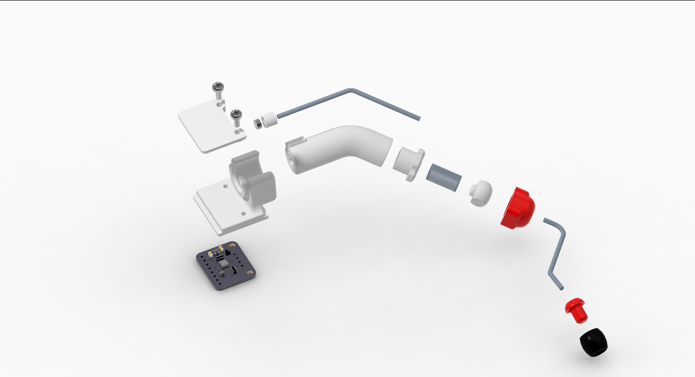

4.2

4.7

4.6

4.5

4.4

4.3

4.8

4.9

4.10

4.11

4.12

4.13

4.14

4.15

4.1

|  |  |
| --- | --- |
| N° | Mechanical part description |
| 4.1 | Magnetometer top cover |
| 4.2 | Cylindrical head screw M2.5x6 (2x) |
| 4.3 | Magnetometer support |
| 4.4 | Adafruit MLX90393 |
| 4.5 | Axial disc magnet |
| 4.6 | Magnet holder |
| 4.7 | Top beam |
| 4.8 | Right or Left tube |
| 4.9 | Spring holder part 1 |
| 4.10 | Traction spring of 13 mm long |
| 4.11 | Spring holder part 2 |
| 4.12 | Spherical socket |
| 4.13 | Bottom beam |
| 4.14 | End part holder |
| 4.15 | Rubber end part |

### Fabrication process

Both (left/right) probes share the same process except step 4.5 which involve different (left/right) tubes *(Part N°4.8).*

MATERIALS NEEDED can be found in Mechanical Part List (MPL, page 24), Printed Parts List (PPL, page 25) and Electronical part list (EPL, page 22)

|  |  |  |
| --- | --- | --- |
| Step | Description | Materials needed |
| 1 | **Top and bottom Beams *(Parts N°4.7, 4.13)***  Make the top *(Part N°4.7)* and bottom *(Part N°4.13)* beams as illustrated with a steel wire of Ø2 mm. | * Steel wire of Ø2 mm *(MPL N°10)* * Pattern for the top beam:      * Pattern for the bottom beam: |
| 2 | **Elastic coupling assembly *(Parts N°4.9, 4.10, 4.11)***   1. Cut the traction spring of 1m long to have (2x) a 13 mm piece *(Part N°4.10).* 2. Apply metal glue inside of each spring holder *(Part N°4.9, 4.11)* and fix them to each side of the 13mm long traction spring *(Part N°4.10).* 3. Let the glue dry during 2 hours before continuing. | * Traction spring of 1m long *(MPL N°11)* * Spring holder part 1 *(PPL N°18)* * Spring holder part 2 *(PPL N°19)* * Metal glue: CYANOACRYLATE INSTANT ADHESIVES such as Ergo®5011 or Ergo®5901 |
| 3 | **Top beam and elastic coupling assembly *(Part N°4.7 – Step 4.2)***   1. Fill the central hole in the spring holder part 2 *(Part N°4.11)* with metal glue. 2. Insert the spring side of the top beam *(Part N°4.7)* into the elastic coupling *(Step 4.2)* and guide it through the glued central hole *(step 4.3.1)* in the spring holder part. | * Top beam *(Step 4.1)* * Elastic coupling *(Step 4.2)* * Metal glue: CYANOACRYLATE INSTANT ADHESIVES such as Ergo®5011 or Ergo®5901 |
| 4 | **Bottom beam assembly *(Parts N°4.13, 4.12, 4.14, 4.15)***   1. Apply metal glue on both ends of the bottom beam *(Part N°4.13).* 2. Insert the spring side of the bottom beam *(step 4.1.2)* through the spherical socket central hole *(Part N°4.12).* 3. Insert the rubber side of the bottom beam *(step 4.1.2)* through the end-part holder *(Part N°4.14)* central hole. 4. Insert the end-part holder *(Part N°4.14)* into the rubber end-part *(Part N°4.15).* 5. Let the glue dry before continuing. | * Bottom beam *(Step 4.1)* * Spherical socket *(PPL N°20)* * End-part holder *(PPL N°21)* * Rubber end-part *(MPL N°13)* * Metal glue: CYANOACRYLATE INSTANT ADHESIVES such as Ergo®5011 or Ergo®5901 |
| 5 | **Mobile unit assembly *(Parts N°4.5, 4.6 – Step 4.3, 4.4)***   1. Assemble the resulting parts from steps 4.3 and 4.4 by inserting the spring holder part 2 *(Part N°4.11)* into the spherical socket *(Part N°4.12)*. 2. Insert the resulting part from step 4.5.1 through the tube (left/right) *(Part N°4.8).* 3. Insert the magnet side of the top beam *(step 4.1.1)* into the magnet holder. 4. Place the axial disc magnet into the magnet holder *(Part N°4.6).* | * Top beam and elastic coupling   assembly *(Step 4.3)*   * Bottom beam assembly *(Step 4.4)* * Magnet holder *(PPL N°15)* * Axial disc magnet *(MPL N°12)* * Right/left tube *(PPL N°16, 17)* |

|  |  |  |
| --- | --- | --- |
| 6 | Fixed and mobile unit assembly *(Parts N°4.1, 4.2, 4.3, 4.4 – Step 4.5)*   1. Fix the Adafruit MLX90393 *(Part N°4.4)* between the magnetometer support *(Part N°4.3)* and the magnetometer top cover *(Part N°4.1)* using (2x) cylindrical head screws M2.5x6 *(Part N°4.2).* 2. Slide the mobile unit *(Step 4.5)* into the magnetometer support *(Part N°4.3).* | * Adafruit MLX90393 *(EPL N°3)* * Magnetometer support   *(PPL N°14)*   * Magnetometer top cover   *(PPL N°13)*   * Cylindrical head screw M2.5x6 *(MPL N°9)* * Mobile unit assembly *(Step 4.5)* |
| 7 | **Electrical wiring *(Parts N°2, 3, 4.4)***   1. Insert the JST SH 4-PIN cable (connector side) in the right side of the QWIIC I2C ADAPTER *(Part N°2.12, 3.3)*. 2. Connect the JST SH 4-PIN cable (wires side)to the Adafruit MLX90393 *(Part N°4.1)*following the electrical schematic (Pag. 23). | * Adafruit MLX90393 *(EPL N°3)* * JST SH 4-PIN cable *(EPL N°12)* * QWIIC I2C ADAPTER *(EPL N°9)* |
| 8 | **Assembly with the right or left hub (Parts N° 2, 3 – Step 4.7)**  Slide the assembly from step 4.7 into the bottom part of the right/left hub following the general assembly (Pag. 5). | * Right hub *(Part N°2)* * Left hub *(Part N°3)* |

## Optical probe sub-assembly

The optical probe *(Part N°5)* measures voluntary forehead movements. A flexible metal conduit *(Part N°5.5)* and a sliding join *(Parts N°5.6, 5.7)* allow to finely adjusting the position and orientation of the optical sensing unit *(Parts N°5.1, 5.4)* respect the forehead.

|  |  |  |  |  |  |  |  |  |  |  |  |  |  |  |  |  |  |  |  |  |  |  |  |
| --- | --- | --- | --- | --- | --- | --- | --- | --- | --- | --- | --- | --- | --- | --- | --- | --- | --- | --- | --- | --- | --- | --- | --- |
|  | |  |  | | --- | --- | | N° | Mechanical part description | | 5.1 | Optical sensor case | | 5.2 | White LED [L3-W36N-BVW](https://www.distrelec.ch/fr/led-3mm-rond-blanc-9cd-sloan-l3-w36n-bvw/p/17524118?track=true&no-cache=true&marketingPopup=false) | | 5.3 | Phillips screw M2x6 (2x) | | 5.4 | Optical sensor PCB | | 5.5 | Flexible metal conduit | | 5.6 | Sliding join male | | 5.7 | Sliding join female | | 5.8 | 8pos 1.27mm male connector | | 5.9 | 8pos 1.27mm female connector | | 5.10 | Wires cover | |

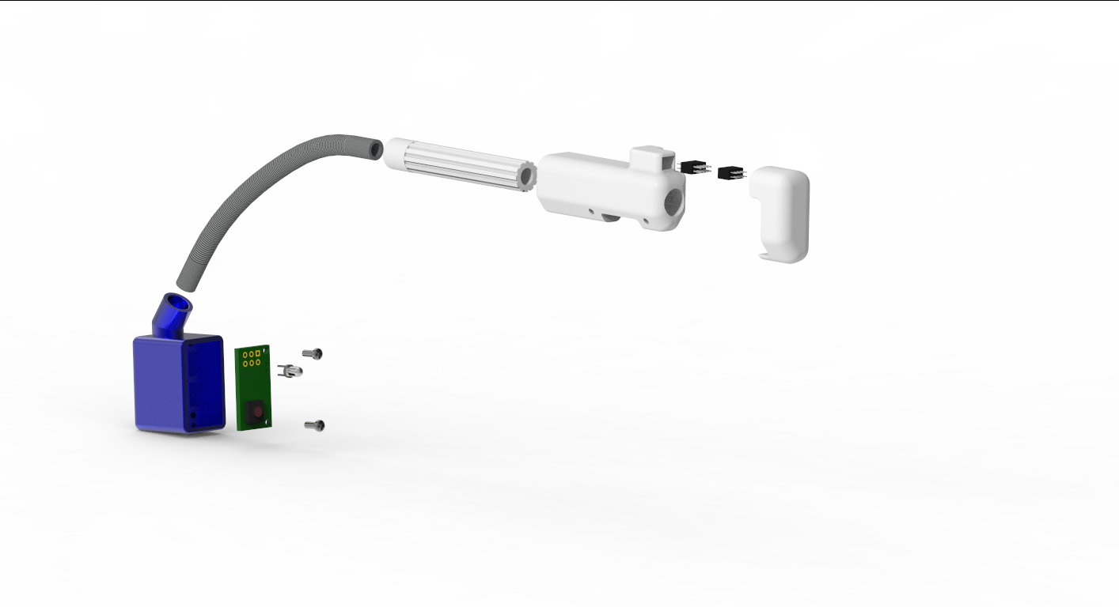

5.1

5.2

5.3

5.4

5.5

5.6

5.7

5.8

5.10

5.9

### Fabrication process

MATERIALS NEEDED can be found in Mechanical Part List (MPL, page 24), Printed Parts List (PPL, page 25) and Electronical part list (EPL, page 22)

|  |  |  |
| --- | --- | --- |
| Step | Description | Materials needed |
| 1 | **Flexible metal conduit *(Part N°5.5)***  Cut a piece 136mm long of Interlock Type-C Conduit. | * Flexible metal Conduit of 10m *(MPL N°8)* |
| 2 | **Housing assembly *(Parts N°5.1, 5.5, 5.6)***   1. Insert one end of the flexible metal conduit *(Part N°5.5)* into the optical sensor case *(Part N°5.1)* side opening. 2. Insert the other end of the flexible metal conduit *(Part N°5.5)* into the sliding join male *(Part N°5.6).* 3. Secure the assembly applying metal glue at around the contours interfacing the flexible metal conduit *(Part N°5.5)* with the optical sensor case *(Part N°5.1)* and the sliding join male *(Part N°5.6).* 4. Let the glue dry before continuing. | * Optical sensor case *(PPL N°9)* * Flexible metal conduit *(Step 5.1)* * Sliding join male *(PPL N°10)* * Metal glue: CYANOACRYLATE INSTANT ADHESIVES such as Ergo®5011 or Ergo®5901 |
| 3 | **Sensing unit assembly *(Parts N°5.2, 5.4)***   1. Drill the optical sensor PCB *(Part N°5.4)* with 2x 1mm diameter holes as indicated in the figure in yellow. 2. Insert the white LED *(Part N°5.2)* pins through the drilled holes in step 5.3.1. 3. Secure the white LED *(Part N°5.2)* on the optical sensor PCB *(Part N°5.4)* with hot glue. | * White LED *(EPL N°7)* * Optical sensor PCB *(PCB-PL P.21,*   *EPL N°4)*   * Driller (tool) * Silicone hot gun (tool) |

|  |  |  |
| --- | --- | --- |
| 4 | Electrical wiring   1. Cut 8 wires with a length of 150 mm and solder them with the pins of the optical sensor. 2. Twist the wires and pass them through the probe created at the step 2 by the side of the optical sensor case *(Part N°5.1).* 3. Solder the wires coming out of the sliding join male *(Part N°5.6)* with the female connector *(Part N°5.9)* according to the figure beside. 4. Cut 8 electric wires and solder them on the Male connector *(Part N°5.8).* 5. Insert the Male connector *(Part N° 5.8)* with the soldered wires inside the housing located on the Sliding join female *(Part N°5.7).* 6. Secure the Male connector *(Part N°5.8)* on the Sliding join female *(Part N°5.7)* with hot glue. 7. Assemble the Sliding join female *(Part N°5.7)* above the right hub. 8. Solder the wires coming out of the Sliding join female *(Part N°5.7)* with the Bluefruit NRF52 Feather *(Part N°2.4)* according to the electrical schematic (Pag. 23). | * 28AWG wires or 30AWG wires * Silicone hot gun (tool) * Sliding join female *(PPL N°11)* |

## Optical sensor circuit schematic

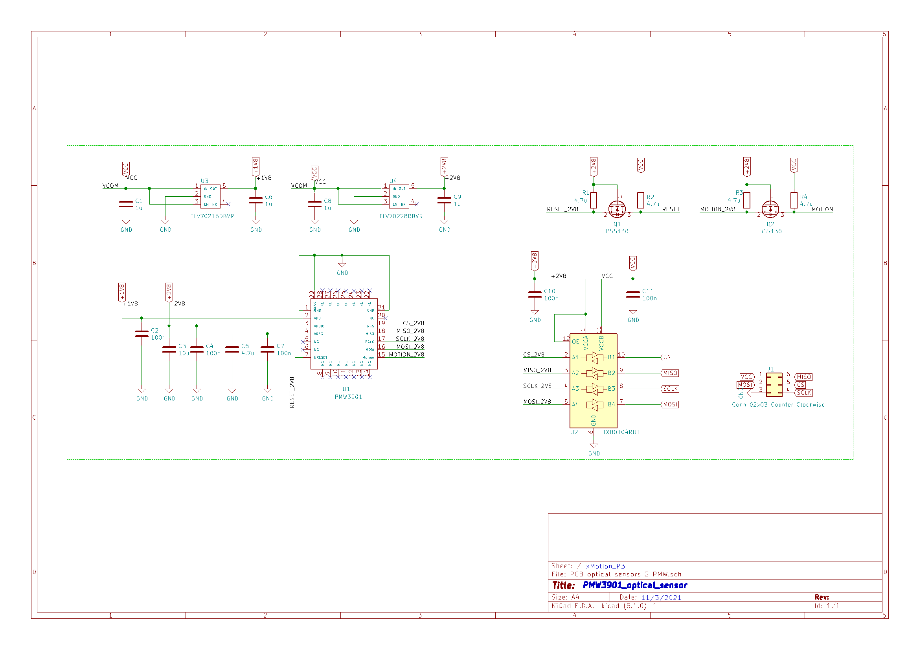

## PCB optical sensor Layout

|  |  |
| --- | --- |
|  |  |

**Back View**

**Front View**

## PCB optical sensor parts list (PCB-PL)

|  |  |  |  |  |
| --- | --- | --- | --- | --- |
| N° | PCB part description | Quantity | Datasheet | Supplier link |
| 1 | Motion tracking sensor PMW3901 | 1 | CP-EX3051WN Datasheet - Hitachi Digital Media Group | [PMW3901MB-TXQT](https://www.codico.com/de/pmk3903is-sample-kit-cdc) |
| 2 | Translation Bidirectional 4-channel voltage levels | 1 | CP-EX3051WN Datasheet - Hitachi Digital Media Group | [TXB0104RUTR](https://www.mouser.ch/ProductDetail/595-TXB0104RUTR) |
| 3 | MOSFET SOT-23 N-CH LOGIC BSS138 | 2 | CP-EX3051WN Datasheet - Hitachi Digital Media Group | [BSS138](https://www.mouser.ch/ProductDetail/512-BSS138) |
| 4 | SMD resistors 0603 4.7KΩ 5% | 4 | CP-EX3051WN Datasheet - Hitachi Digital Media Group | [SFR03EZPJ472](https://www.mouser.ch/ProductDetail/755-SFR03EZPJ472) |
| 5 | TLV70218 Voltage regulators 1.8V, LDO, 300mA | 1 | CP-EX3051WN Datasheet - Hitachi Digital Media Group | [TLV70218DBVR](https://www.mouser.ch/ProductDetail/Texas-Instruments/TLV70218DBVR?qs=%2Fha2pyFaduiaVM%252BCD%252BhizitOsgx1Oc1cvRJN91SwHug%2F2hs2vQbE%2FQ%3D%3D) |
| 6 | TLV70228 Voltage regulators 2.8V, LDO, 300mA | 1 | CP-EX3051WN Datasheet - Hitachi Digital Media Group | [TLV70228DBVR](https://www.mouser.ch/ProductDetail/595-TLV70228DBVR) |
| 7 | Ceramic Capacitors SMD 6.3V 100nF 0603 10% | 3 | CP-EX3051WN Datasheet - Hitachi Digital Media Group | [0603C104K5RECAUTO7411](https://www.mouser.ch/ProductDetail/80-C0603C104K5REAULR) |
| 8 | Ceramic Capacitors SMD 6.3V 1uF 0603 10% | 4 | CP-EX3051WN Datasheet - Hitachi Digital Media Group | [C0603C105K9RAC7411](https://www.mouser.ch/ProductDetail/80-C0603C105K9R7411) |
| 9 | Ceramic Capacitors SMD 6.3V 4.7uF 0603 10% | 1 | CP-EX3051WN Datasheet - Hitachi Digital Media Group | [GMK107BBJ475KA-T](https://www.mouser.ch/ProductDetail/963-GMK107BBJ475KA-T) |
| 10 | Ceramic Capacitors SMD 6.3V 10uF 0603 10% | 1 | CP-EX3051WN Datasheet - Hitachi Digital Media Group | [C0603C106M8PACTU](https://www.mouser.ch/ProductDetail/80-C0603C106M8PACTU) |

## 

## Electronic parts list (EPL)

|  |  |  |  |  |
| --- | --- | --- | --- | --- |
| N° | Part description | Quantity | Datasheet | Supplier Link |
| 1 | Bluefruit nRF52 Feather | 1 | CP-EX3051WN Datasheet - Hitachi Digital Media Group | [Nrf52](https://www.digikey.ch/product-detail/fr/adafruit-industries-llc/3406/1528-2095-ND/7034992) |
| 2 | Rechargeable battery Li-Po 3.7V 350mAh | 1 | CP-EX3051WN Datasheet - Hitachi Digital Media Group | [ICP602823PA](https://www.distrelec.ch/fr/batterie-accumulateurs-rechargeable-li-po-7v-350mah-renata-icp602823pa-01/p/30158722?q=batterie+lipo&pos=18&origPos=18&origPageSize=50&track=true) |
| 3 | Triple-axis Magnetic sensor | 2 | CP-EX3051WN Datasheet - Hitachi Digital Media Group | [MLX90393](https://www.digikey.ch/product-detail/fr/adafruit-industries-llc/4022/1528-2864-ND/9924180) |
| 4 | Motion tracking optical sensor | 1 | CP-EX3051WN Datasheet - Hitachi Digital Media Group | [PMW3901](https://www.digikey.ch/product-detail/fr/pimoroni-ltd/PIM453/1778-PIM453-ND/10246386) |
| 5 | Slide Switch ON/OFF | 1 | CP-EX3051WN Datasheet - Hitachi Digital Media Group | [RND 210-00581](https://www.distrelec.ch/en/miniature-slide-switch-1co-on-on-soldering-lugs-rnd-components-rnd-210-00581/p/30152605?origPos=61&q=&pos=61&no-cache=true&origPageSize=50&track=true&marketingPopup=false) |
| 6 | Push button | 2 | CP-EX3051WN Datasheet - Hitachi Digital Media Group | [PTS647SK70](https://www.digikey.fr/product-detail/fr/PTS+647+SK70+SMTR2+LFS/PTS647SK70SMTR2LFSCT-ND/9649865/?itemSeq=357957130) |
| 7 | White LED | 1 | CP-EX3051WN Datasheet - Hitachi Digital Media Group | [L3-W36N-BVW](https://www.distrelec.ch/fr/led-3mm-rond-blanc-9cd-sloan-l3-w36n-bvw/p/17524118?track=true&no-cache=true&marketingPopup=false) |
| 8 | Green LED | 2 | CP-EX3051WN Datasheet - Hitachi Digital Media Group | [WP7113LGD](https://www.digikey.ch/products/fr/optoelectronics/led-indication-discrete/105?k=754-1265) |
| 9 | QWIIC I2C ADAPTER | 2 | CP-EX3051WN Datasheet - Hitachi Digital Media Group | [DEV-14495](https://www.digikey.fr/product-detail/en/sparkfun-electronics/DEV-14495/1568-1785-ND/7942483?cur=EUR&lang=en) |
| 10 | 8pos 1.27mm female connector | 1 | CP-EX3051WN Datasheet - Hitachi Digital Media Group | [200213](https://www.digikey.ch/product-detail/fr/amphenol-icc-fci/20021311-00008T4LF/609-3753-ND/2209076) |
| 11 | 8pos 1.27mm male connector | 1 | CP-EX3051WN Datasheet - Hitachi Digital Media Group | [20021111](https://www.digikey.ch/product-detail/fr/amphenol-icc-fci/20021111-00008T4LF/609-3711-ND/2209071) |
| 12 | JST SH 4-PIN cable | 2 | CP-EX3051WN Datasheet - Hitachi Digital Media Group | [4209](https://www.digikey.fr/product-detail/fr/4209/1528-4209-ND/10230003/?itemSeq=357957125) |
| 13 | 6-contacts flat cable | 300 mm | CP-EX3051WN Datasheet - Hitachi Digital Media Group | [flat cable](https://www.digikey.fr/product-detail/fr/molex-temp-flex/1000570030/MTF1000-1-ND/8566119) |

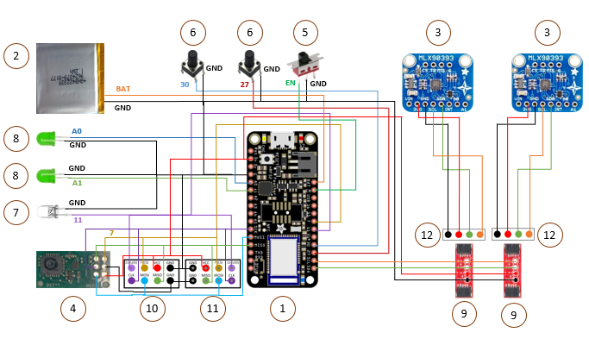

## General circuit schematic

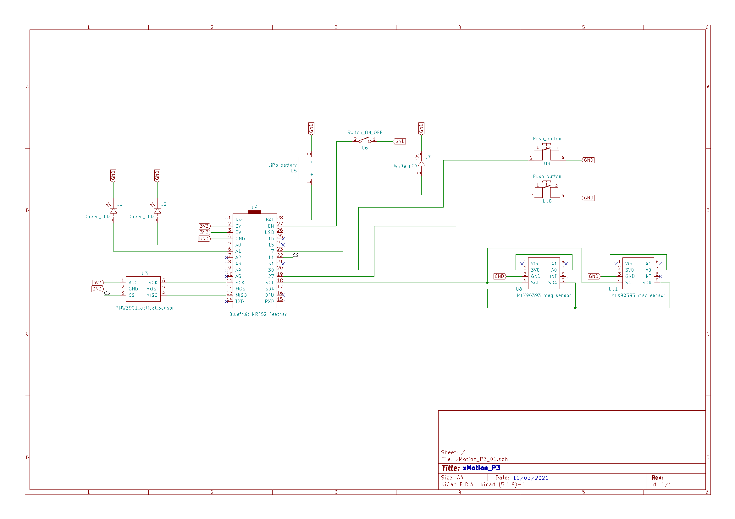

## Mechanical parts list (MPL)

ASSEMBLY: Headset band (HB), Right hub (RH), Left hub (LH), Magnetic probe (MP), Optical probe (OP)

|  |  |  |  |  |
| --- | --- | --- | --- | --- |
| N° | Part description | Assembly | Quantity | Link |
| 1 | Allen screw M3x10 | HB | 2 | [[M3x10]](https://www.bossard.com/eshop/fr-fr/vis-s-a-entrainement-interieur/vis-a-tete-cylindrique-a-six-pans-creux-entierement-filetees/p/3/?category=01.100.100.10&index=1&q=%3Arelevance%3A19D20820-0A5D-4344-AF13-2431AAD21588%3ACylindrique%3A74EC6A2E-3795-43DB-A517-12F3521785C5%3ASix%2Bpans%2Bcreux%3A709F6DBD-590D-4354-A89E-D804F869B1C8%3Aenti%25C3%25A8rement%2Bfilet%25C3%25A9e%3AA87579DF-7F9C-4535-9A8D-87830D3D5D84%3AAcier&variants-query=%3Arelevance%3A19D20820-0A5D-4344-AF13-2431AAD21588%3ACylindrique%3A74EC6A2E-3795-43DB-A517-12F3521785C5%3ASix%2Bpans%2Bcreux%3A709F6DBD-590D-4354-A89E-D804F869B1C8%3Aenti%25C3%25A8rement%2Bfilet%25C3%25A9e%3AA87579DF-7F9C-4535-9A8D-87830D3D5D84%3AAcier%3AF527C156-7E58-11D4-97D3-0000E8601B71%3AM3%3AF527C1B7-7E58-11D4-97D3-0000E8601B71%3A10) |
| 2 | Spring wire of Ø1.6 mm | HB, RH, LH | 1 (m) | [[Spring wire]](https://www.durovis.ch/index.php/fr/shop-ressorts-normalises/fil-ressort-standard-disponible.html) |
| 3 | Memory foam of 12mm thickness | HB, RH | A4 (210 x 297 mm) | [[Foam 1]](https://www.digikey.fr/product-detail/fr/CFNT-EGS+12MM+A4/EAR1041-ND/6226691/?itemSeq=355418852) |
| 4 | Thin foam of 3 mm thickness | HB | A4 (210 x 297 mm) | [[Foam 2]](https://www.digikey.fr/product-detail/fr/3m-aearo-technologies-llc/CF45EG-3MM-A4/EAR1025-ND/6226675) |
| 5 | Flat head screw M2.5x8 | RH, RL | 10 | [[M2.5x8]](https://www.bossard.com/eshop/fr-fr/vis-s-a-entrainement-interieur/vis-a-tete-fraisee-avec-empreinte-cruciforme-phillips-forme-h/p/661/?category=01.100.100.10&index=1&q=%3Arelevance%3A19D20820-0A5D-4344-AF13-2431AAD21588%3AFrais%25C3%25A9e%3A74EC6A2E-3795-43DB-A517-12F3521785C5%3AEmpreinte%2Bcruciforme%2BH%2B%2528Phillips%2529) |
| 6 | Thin tissue for covering | RH, RL | 500 mm2 | [[tissue]](https://www.kreando.ch/fr/similicuir-qualite-souple-nappa-noir/) |
| 7 | Philipps screw M2x6 | OP | 2 | [[M2x6]](https://www.bossard.com/eshop/fr-fr/vis-s-a-entrainement-interieur/vis-a-tete-cylindrique-avec-empreinte-cruciforme-phillips-forme-h/p/380/?category=01.100.100&index=0&q=%3Arelevance%3Acategory%3A01.100.100%3Acategory%3A01.100.100.20%3A74EC6A2E-3795-43DB-A517-12F3521785C5%3AEmpreinte%2Bcruciforme%2BH%2B%2528Phillips%2529&variants-query=%3Arelevance%3Acategory%3A01.100.100%3Acategory%3A01.100.100.20%3A74EC6A2E-3795-43DB-A517-12F3521785C5%3AEmpreinte%2Bcruciforme%2BH%2B%2528Phillips%2529%3AF527C156-7E58-11D4-97D3-0000E8601B71%3AM2%3AF527C1B7-7E58-11D4-97D3-0000E8601B71%3A6) |
| 8 | Flexible metal Conduit of 10m | OP | 10 m | [IS-4N](https://www.hagitec.de/index.php/en/products/flexible-metal-conduits/flexible-metal-conduits-product-list/interlock-type-c-conduit) |
| 9 | Cylindrical head screw M2.5x6 | MP | 4 | [[M2.5x6]](https://www.bossard.com/eshop/fr-fr/vis-s-a-entrainement-interieur/vis-a-tete-cylindrique-avec-empreinte-cruciforme-phillips-forme-h/p/381/?category=01.100.100.10&index=1&q=%3Arelevance%3A19D20820-0A5D-4344-AF13-2431AAD21588%3ACylindrique%2Bbasse%3A19D20820-0A5D-4344-AF13-2431AAD21588%3ACylindrique%2Bplate%3A19D20820-0A5D-4344-AF13-2431AAD21588%3ACylindrique%3A74EC6A2E-3795-43DB-A517-12F3521785C5%3AEmpreinte%2Bcruciforme%2BH%2B%2528Phillips%2529) |
| 10 | Steel wire of Ø2mm | MP | 500 mm | [[Steel wire]](https://www.jumbo.ch/fr/bobine-de-fil-de-fer-galvanise-26505?sku=1096747) |
| 11 | Traction spring of 1m long | MP | 1 m | [[Spring]](https://www.durovis.ch/index.php/fr/shop-ressorts-normalises/ressorts-de-traction-de-1-metre-disponibles.html?spec=sku:06/4) |
| 12 | Axial disc magnet | MP | 2 | [[Magnet]](https://www.supermagnete.ch/fre/aimants-disques-neodyme/disque-magnetique-4mm-2mm_S-04-02-N) |
| 13 | Rubber end-part | MP | 2 | [[Rubber]](https://www.digitec.ch/en/s1/product/sennheiser-ear-adapter-headphone-spare-parts-280598) |

## Printed parts list (PPL)

ASSEMBLY: Headset band (HB), Right hub (RH), Left hub (LH), Magnetic probe (MP), Optical probe (OP)

|  |  |  |  |  |  |
| --- | --- | --- | --- | --- | --- |
| N° | Part description | Assembly | Quantity | Part name | Printing material |
| 1 | Flexible top cover | HB | 1 | [flexible_top_cover.stl](../../../Hardware/Mechanical%20Design/Release/Headset%20band/STL) | TPU |
| 2 | Right side node | HB | 1 | right_side_node.stl | Tough PLA or ABS |
| 3 | Left side node | HB | 1 | left_side_node.stl | Tough PLA or ABS |
| 4 | Locking wheel | HB | 2 | locking_wheel.stl | TPU |
| 5 | Flexible headband | HB | 1 | flexible_headband.stl | TPU |
| 6 | Right hub cover | RH | 1 | [right_hub_cover.stl](../../../Hardware/Mechanical%20Design/Release/Right%20hub/STL) | Tough PLA or ABS |
| 7 | Hub end part | RH, LH | 2 | [hub_end_part.stl](../../../Hardware/Mechanical%20Design/Release/Right%20hub/STL) | Tough PLA or ABS |
| 8 | Right hub holder | RH | 1 | [right_hub_holder.stl](../../../Hardware/Mechanical%20Design/Release/Right%20hub/STL) | Tough PLA or ABS |
| 9 | Left hub holder | LH | 1 | [left_hub_holder.stl](../../../Hardware/Mechanical%20Design/Release/Left%20hub/STL) | Tough PLA or ABS |
| 10 | Left hub cover | LH | 1 | [left_hub_cover.stl](../../../Hardware/Mechanical%20Design/Release/Left%20hub/STL) | Tough PLA or ABS |
| 9 | Optical sensor case | OP | 1 | [optical_sensor_case.stl](../../../Hardware/Mechanical%20Design/Release/Optical%20probe/STL) | Tough PLA or ABS |
| 10 | Sliding join male | OP | 1 | [sliding_join_male.stl](../../../Hardware/Mechanical%20Design/Release/Optical%20probe/STL) | Tough PLA or ABS |
| 11 | Sliding join female | OP | 1 | [sliding_join_female.stl](../../../Hardware/Mechanical%20Design/Release/Optical%20probe/STL) | Tough PLA or ABS |
| 12 | Wires cover | OP | 1 | [wires_cover.stl](../../../Hardware/Mechanical%20Design/Release/Optical%20probe/STL) | Tough PLA or ABS |
| 13 | Magnetometer top cover | MP | 2 | [magnetometer_top_cover.stl](../../../Hardware/Mechanical%20Design/Release/Magnetic%20probe/STL) | Tough PLA or ABS |
| 14 | Magnetometer  support | MP | 2 | [magnetometer_support.stl](../../../Hardware/Mechanical%20Design/Release/Magnetic%20probe/STL) | Tough PLA or ABS |
| 15 | Magnet holder | MP | 2 | [magnet_holder.stl](../../../Hardware/Mechanical%20Design/Release/Magnetic%20probe/STL) | Tough PLA or ABS |
| 16 | Right tube | MP | 1 | [right_tube.stl](../../../Hardware/Mechanical%20Design/Release/Magnetic%20probe/STL) | Tough PLA or ABS |
| 17 | Left tube | MP | 1 | [left_tube.stl](../../../Hardware/Mechanical%20Design/Release/Magnetic%20probe/STL) | Tough PLA or ABS |
| 18 | Spring holder part 1 | MP | 2 | [spring_holder_part1.stl](../../../Hardware/Mechanical%20Design/Release/Magnetic%20probe/STL) | Tough PLA or ABS |
| 19 | Spring holder part 2 | MP | 2 | [spring_holder_part1.stl](../../../Hardware/Mechanical%20Design/Release/Magnetic%20probe/STL) | Tough PLA or ABS |
| 20 | Spherical socket | MP | 2 | [spherical_socket.stl](../../../Hardware/Mechanical%20Design/Release/Magnetic%20probe/STL) | TPU |
| 21 | End-part holder | MP | 2 | [end_part_holder.stl](../../../Hardware/Mechanical%20Design/Release/Magnetic%20probe/STL) | Tough PLA or ABS |